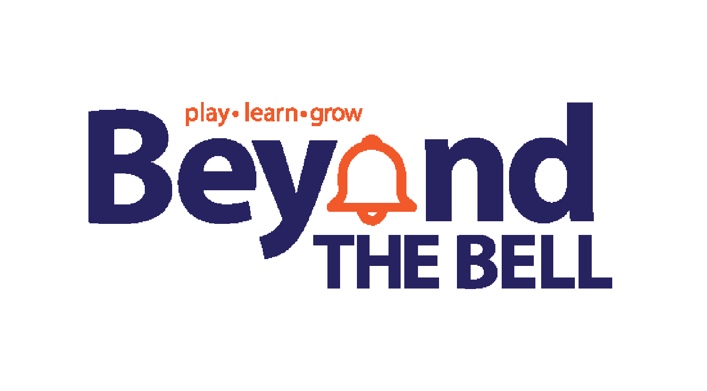
Job Description
Title: Site Leader
Summary: Under the supervision of the Beyond the Bell Multi-Site Manager, the Site Leader is responsible for oversight of all on site programming, implementing activities and the supervision of the Beyond the Bell site employees and of youth enrolled in Beyond the Bell programs. The Site Leader is tasked with the goal of ensuring quality programming, and proper student and staff supervision. To perform this job successfully, an individual must be able to perform each primary responsibility satisfactorily. Reasonable accommodations may be made to enable individuals with disabilities to perform the primary job responsibilities. This position reports directly to the Multi-Site Manager.
Terms of Employment:
- Work Hours:
  - AM Monday-Friday 6:30 A.M.-8:30 A.M. (Sioux City elementary sites only)
  - PM- Monday (Sioux City 2:00-6:00 PM) (South Sioux 1:30-6:00 PM)
  - PM Tuesday-Friday (Sioux City 3:00-6:00 PM) (South Sioux 2:30-6:00 PM)
    - Max of 29 hours weekly
- Locations: Sioux City Elementary and Middle School, South Sioux City Elementary, Bishop Heelan
- Beyond the Bell is a licensed childcare provider requiring mandatory training, physical, background check and fingerprinting before employment can begin
- This position is a temporary part time position
- Positions starts at $16 an hour (effective 8.1.2023)
Qualifications for positions in Iowa:
- Must be at least 18 years of age or older
- High School Diploma or General Education Diploma
- CPR/First Aid Certification
- Child Abuse Certificate (Mandatory Reporting)
- 75 total points required per DHS Qualifications in a minimum of two categories with no more than 50 points in any one category- Education, Experience, Child Development Related Training
- Must be able to work all scheduled program hours for AM and PM programs
- Education, Early Childhood, Elementary Education, reading and/or special education preferred or must meet state requirements to qualify as a lead
- Must be able to meet/obtain certification in all organizational, local, state, and federal licensing and training requirements including but not limited to CPR, First Aid, and Mandatory Reporting, Universal Precautions, DHS Essentials, Passport to ECE and others that may come up
- Must be willing to attend periodic staff meeting and trainings after normal work hours and possibly weekends
- Ability to adjust teaching methods to meet the needs of students
- Dependable, reliable work/volunteer history
- Reliable transportation to and from the program site
- Reliable daily communication method-either phone or email
- Ability to learn and complete daily administrative tasks- sign in/out of students, accept and record payments
Qualifications for position in Nebraska:
- Must be at least 19 years of age of older
- Must meet one of the following requirements:
  - Hold a Bachelor's degree from an accredited college or university in early childhood education, education or child/youth development
  - Hold a bachelor’s degree from an accredited college or university and at least six credit hours in early childhood education, education or child/youth development;
  - Have an associate degree from an accredited college or university in early childhood education, education or child/youth development
  - Have a Child Development Associate Credential;
  - Have successfully completed six credit hours or 36 hours of Department approved training in administration, early childhood education, education, or child/youth development. Business courses may be included, not to exceed one-half of the credit or clock hour requirements;
  - Have a high school diploma or GED and 3000 clock hours of verifiable experience in organized group activities for school age children as indicated by a positive reference from a former employer or supervisor.
- CPR/First Aid Certification
- Child Abuse Certification (Mandatory Reporting)
- Education, Early Childhood, Elementary Education, reading and/or special education preferred
- Must be able to meet all organizational, local, state, and federal licensing and training requirements including but not limited to CPR, First Aid, and Mandatory Reporting
- Must be willing to attend staff meeting and trainings during normal work hours and possibly evening and weekends
- Experience in supervising people
- Ability to work and plan independently
- Dependable, reliable work/volunteer history
- Reliable transportation to and from the program site
- Reliable daily communication method-either phone or email

Skills, Abilities, Duties, and Responsibilities:
Preferred candidates will have proven success in the following:
- Development and implement daily activities and schedules
- Meet on a daily basis before afternoon program to go over lesson plans and prep staff for the day
  - Responsible for tracking attendance, giving payment receipts, preparing, giving, and recording snacks, providing age appropriate activities, gym games, and free play. Provide space for individual quiet time, and assist with homework and design academic components that connect to schedules
- Supervise and lead activities designed to enhance the health, emotional, social, intellectual, and physical development of children enrolled in the Beyond the Bell program
- Ensure the safety of the children enrolled in the program at all times
- Ensure all school rules are being followed and enforced and follow the policies and procedures of Beyond the Bell
- Meet on a monthly basis with program staff, Multi-Site Manager, Recruitment and Development Specialist, and Academic and Enrichment Specialist to align goals
- Strong communication skills (oral, written, and presentation) and organizational habits
- Leadership in problem solving and decision making & resolve student situations-behavioral, emotional, and first aid
- Maintain professional relationships with the children, parents, and co-workers and treat all with dignity and respect
- Complete general housekeeping to make sure the site is left clean and ready for the next program/day
- Attend all mandatory staff development training planned by Beyond the Bell
- Follow through with disciplinary or redirection actions for youth in program, in accordance with Beyond the Bells policies, guidelines, practices, and procedures
- Ensure that all organizational, local, state and federal program guideline are being met and followed at assigned site
- Display strong organizational skills
- An ability to work well with others who have diverse opinions
- The ability to exercise tact and handle information that is confidential, sensitive or controversial
- The ability to work and plan independently with often remote, but supportive supervision
- Customer Focus and Relationship Building
- Champion for Change and teamwork
- Experience, or a desire to work with school-aged children in a programmed setting
- Available and willing to work at all Beyond the Bell site locations
- Ability and willingness to work independently within ratio requirements at site when needed
- Other duties as assigned

21ST Century Learning Centers Requirements:
Beyond the Bell facilitates 21st CCLC grants. If you are assigned to one of those locations, these additional requirements may apply.
● Participate and contribute in monthly best practice webinars
● Participate and contribute in monthly committee meetings (via phone or zoom)
● Attend annual Iowa Afterschool Impact Conference
● Develop and host monthly family engagement nights

WORKING CONDITIONS:
While performing the duties of this job, the employee is frequently exposed to indoor and outdoor conditions. While performing the duties of this job, the employee is required to frequently stand, walk, stoop, bend, sit, reach, carry, and lift. The noise level in the work environment ranges from mild to loud.
SHIP is an equal opportunity employer. SHIP shall comply with all provisions of federal, state and local laws, rules, and executive orders which apply to insure that no client, employee, or applicant for employment is discriminated against or harassed because of race, color, national origin, religion or creed, age, disability status, genetics, protected veteran status, political affiliation, sex (including pregnancy), sexual orientation, gender identity or expression, or any other protected characteristic.

Signed_________________________________________________________Date_________________________

